Howard County 4-H Food and Nutrition Project Record
Name |  |  | 4-H Age
Primary Club Name
Years in 4-H |  |  | Years in this Project
I have completed this record and believe all information to be complete and accurate.

Member’s Signature Date Parent’s Signature Date

Project this record is about:

What goals did you set for your project this year and did you achieve them?
1.

2.

3.

What were two things you learned from completing this project this year?
1.

2.

What is one thing you would like to improve or do differently with your project next year?
Life Skills
Describe the Life Skills you used and what you learned in relation to your project.
Example Table
I used one or more of these Life Skills from the Targeting Life Skills Wheel | What I learned as a result of using this skill.
HEAD  Example: Decision Making | I learned that I needed to be sure to budget my money when purchasing craft supplies so I would have enough to cover all of my expenses.
HEART  Example: Sharing | I learned how to give younger 4-H members pointers on how to make a wreath through a visual presentation.
HAND  Example: Community Service Volunteering | Through my woodworking project, I have learned many new skills. I found it to be beneficial to my community to utilize those woodworking skills when volunteering to build a wheel chair ramp.
HEALTH  Example: Managing Feelings | I learned to control my feelings when I became frustrated that the new cake I baked didn’t rise. Since I didn’t have success with the new cake recipe, I am going to research other options that I could try.

I used one or more of these Life Skills from the Targeting Life Skills Wheel | What I learned as a result of using this skill.
HEAD

HEART

HAND

HEALTH

The diagram below shows many of the Life Skills learned in 4-H:
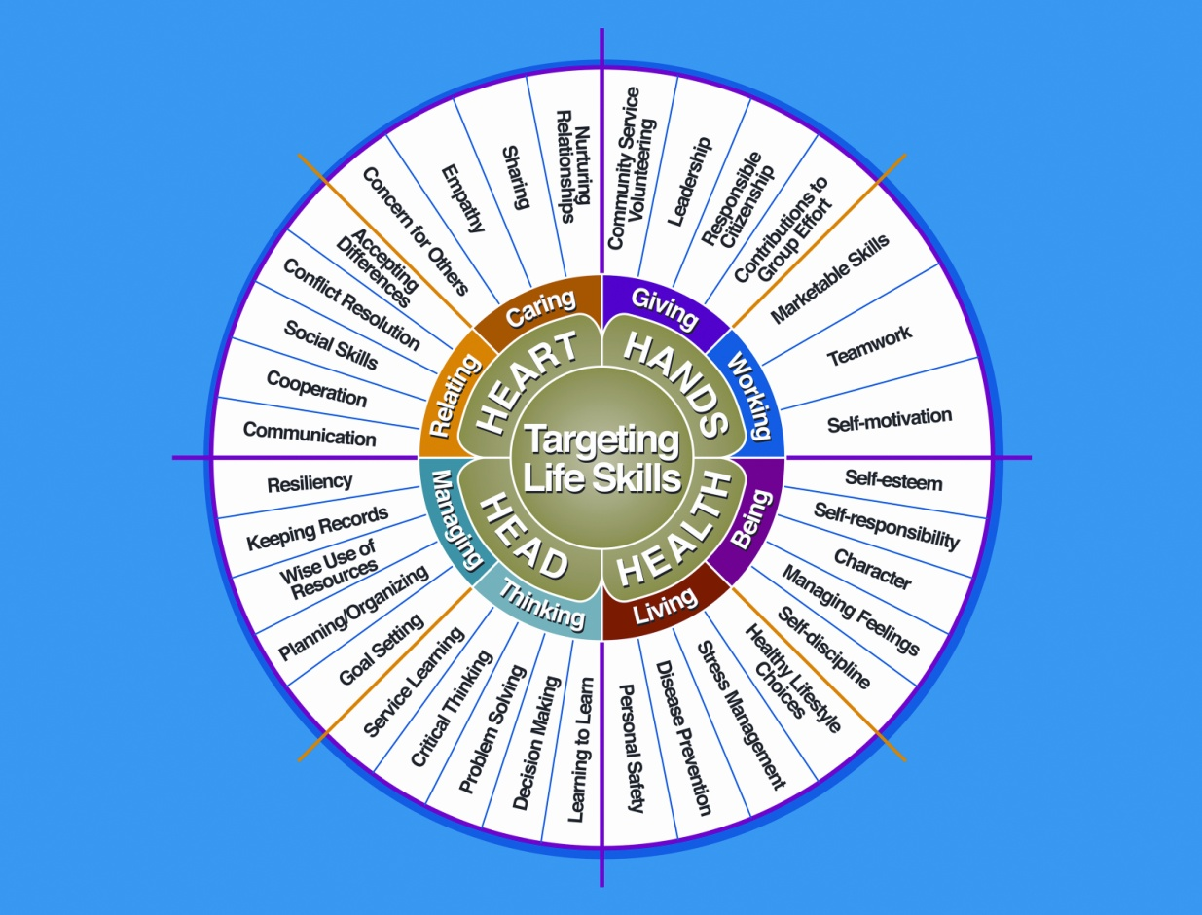

Courtesy of Iowa State University-Used with Permission 11/2012
Project Activities/Learning Experiences
Include: Field Trips, Meetings, Workshops, any Learning Experiences, etc.
All project activities/learning experiences listed should be about this project area only.
Date | Name of Activity/Event/Learning Experience | What I Learned

Project Communications
Include: Speeches, Demonstrations, Visual Presentations, Etc.
All project communications listed should be about this project area only.
Date | Type of Communication | Title | Location  (School, Club, County, Regional, State, National etc.)

Project Exhibits
Include: Fairs, Shows, Community Events, Contests, etc.
All project exhibits listed should be for projects in this area only.
Date | Exhibit/Class | Event/Activity | Placing  (if applicable)

.

Table 1: Project Expenses
Includes: Ingredients, Paint, Wood, Fabric, etc.
Date | Description of Item Purchased | Cost
Total Expenses

Table 2: All Income
Includes: Premiums, Selling Project Work Items, etc.
Date | Description of Income | Income Amount
Total Income

Financial Summary: Please make sure to use the above totals.

Determine how much money you made or lost on your project.
You can determine your profit (or loss) by:

- Income

- Income Total (Table 2) $ ________

Total Income (A) $ ________

- Expenses

- All Expenses (Table 1) $ ________

Total Expenses (B) $ ________

Subtract B from A to get profit or loss Total $ ________ (profit or loss)

University of Maryland Extension programs are open to all and will not discriminate against anyone because of race, age, sex, color, sexual orientation, physical or mental disability, religion, ancestry, or national origin, marital status, genetic information, or political affiliation, or gender identity and expression.

3/2015

